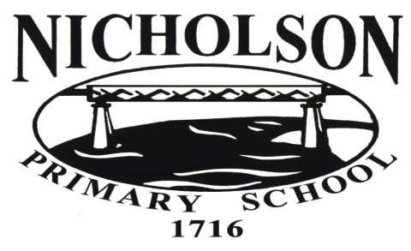

STRUCTURE 2
CHILD SAFETY POLICY

Nicholson Primary School embraces the values of Growth, Honesty & Trust, Respect, Connectedness, Inclusiveness and Fun. We aim to have students recognise their fullest potential through the acquisition of knowledge, skills and values in an environment where they learn and grow to enjoy a productive, rewarding and fulfilling life. In support of this

at Nicholson Primary School, we have a zero tolerance to child abuse.

Rationale

All Victorian schools are required to have a child safety policy or statement of commitment to child safety that details:
- the principles that will guide the school in developing policies and procedures to create and maintain a child safe school environment; and
- the actions the school proposes to take to:
- demonstrate its commitment to child safety and monitor the school's adherence to its child safety policy;
- support, encourage and enable school staff, parents, and children to understand, identify, discuss and report child safety matters; and
- support or assist children who disclose child abuse, or are otherwise linked to suspected child abuse.
- Ensure that child safety is considered in the recruitment, selection and management of staff (includes contractors and volunteers)

Ministerial Order No. 870 (available at www.vrqa.vic.gov.au/childsafe) states that
Child abuse includes –

- Any act committed against a child involving –
- A sexual offence or
- An offence under section 49 B (2) of the Crimes Act 1958 (grooming)
- The infliction, on a child, of –
- Physical violence or
- Serious emotional or psychological harm

- Serious neglect of a child.

Evaluation
This policy will be reviewed in consultation with the whole school community as part of the school’s three-year review cycle.

